UNITED STATES
SECURITIES AND EXCHANGE COMMISSION
Washington, D.C. 20549
SCHEDULE 14A

PROXY STATEMENT PURSUANT TO SECTION 14(a) OF THE
SECURITIES EXCHANGE ACT OF 1934
Filed by the Registrant ☒
Filed by a party other than the Registrant ☐
Check the appropriate box:
☐ Preliminary Proxy Statement
☐ Confidential, for Use of the Commission Only (as permitted by Rule 14a-6(e)(2))
☐ Definitive Proxy Statement
☒ Definitive Additional Materials
☐ Soliciting Material Pursuant to §240.14a-12
PALLADYNE AI CORP.

(Name of Registrant as Specified In Its Charter)

(Name of Person(s) Filing Proxy Statement, if other than the Registrant)
Payment of Filing Fee (Check the appropriate box):
☒ No fee required.
☐ Fee paid previously with preliminary materials.
☐ Fee computed on table in exhibit required by Item 25(b) per Exchange Act Rules 14a-6(i)(1) and 0-11.

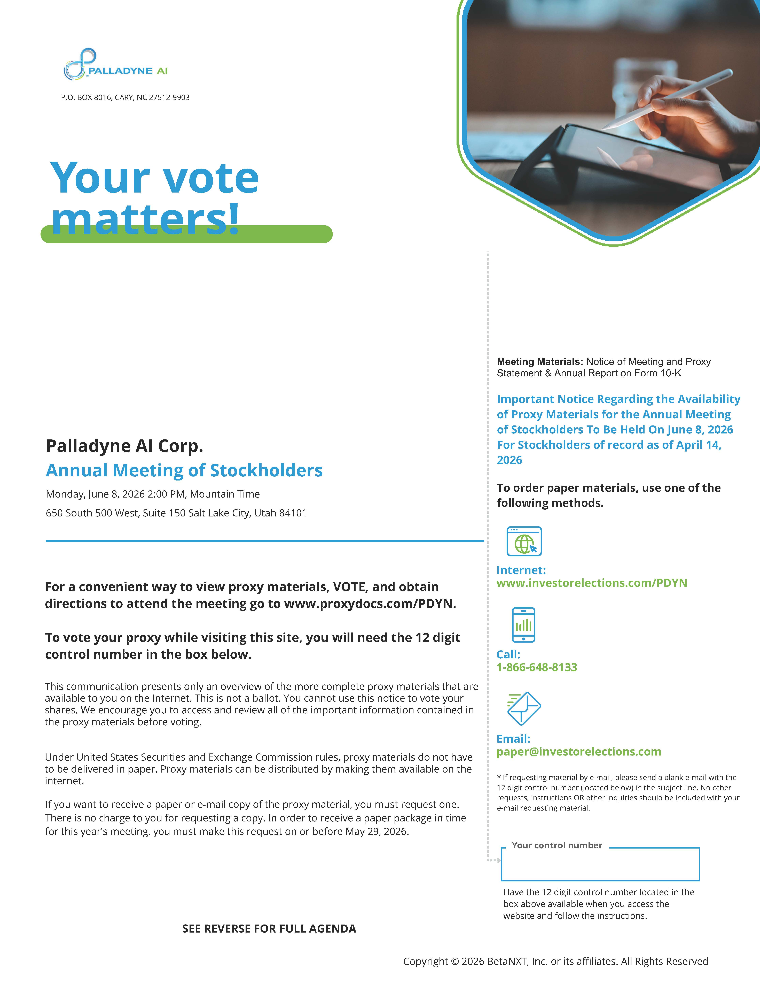
TM PALLADYNE AI P.O. BOX 8016, CARY, NC 27512-9903 Your vote matters! Palladyne AI Corp. Annual Meeting of Stockholders Monday, June 8, 2026 2:00 PM, Mountain Time 650 South 500 West, Suite 150 Salt Lake City, Utah 84101 For a convenient way to view proxy materials, VOTE, and obtain directions to attend the meeting go to www.proxydocs.com/PDYN. To vote your proxy while visiting this site, you will need the 12 digit control number in the box below. This communication presents only an overview of the more complete proxy materials that are available to you on the Internet. This is not a ballot. You cannot use this notice to vote your shares. We encourage you to access and review all of the important information contained in the proxy materials before voting. Under United States Securities and Exchange Commission rules, proxy materials do not have to be delivered in paper. Proxy materials can be distributed by making them available on the internet. If you want to receive a paper or e-mail copy of the proxy material, you must request one. There is no charge to you for requesting a copy. In order to receive a paper package in time for this year's meeting, you must make this request on or before May 29, 2026. SEE REVERSE FOR FULL AGENDA Copyright © 2026 BetaNXT, Inc. or its affiliates. All Rights Reserved Meeting Materials: Notice of Meeting and Proxy Statement & Annual Report on Form 10-K Important Notice Regarding the Availability of Proxy Materials for the Annual Meeting of Stockholders To Be Held On June 8, 2026 For Stockholders of record as of April 14, 2026 To order paper materials, use one of the following methods. Internet: www.investorelections.com/PDYNCall: 1-866-648-8133 Email: paper@investorelections.com* If requesting material by e-mail, please send a blank e-mail with the 12 digit control number (located below) in the subject line. No other requests, instructions OR other inquiries should be included with your e-mail requesting material. Your control number Have the 12 digit control number located in the box above available when you access the website and follow the instructions.

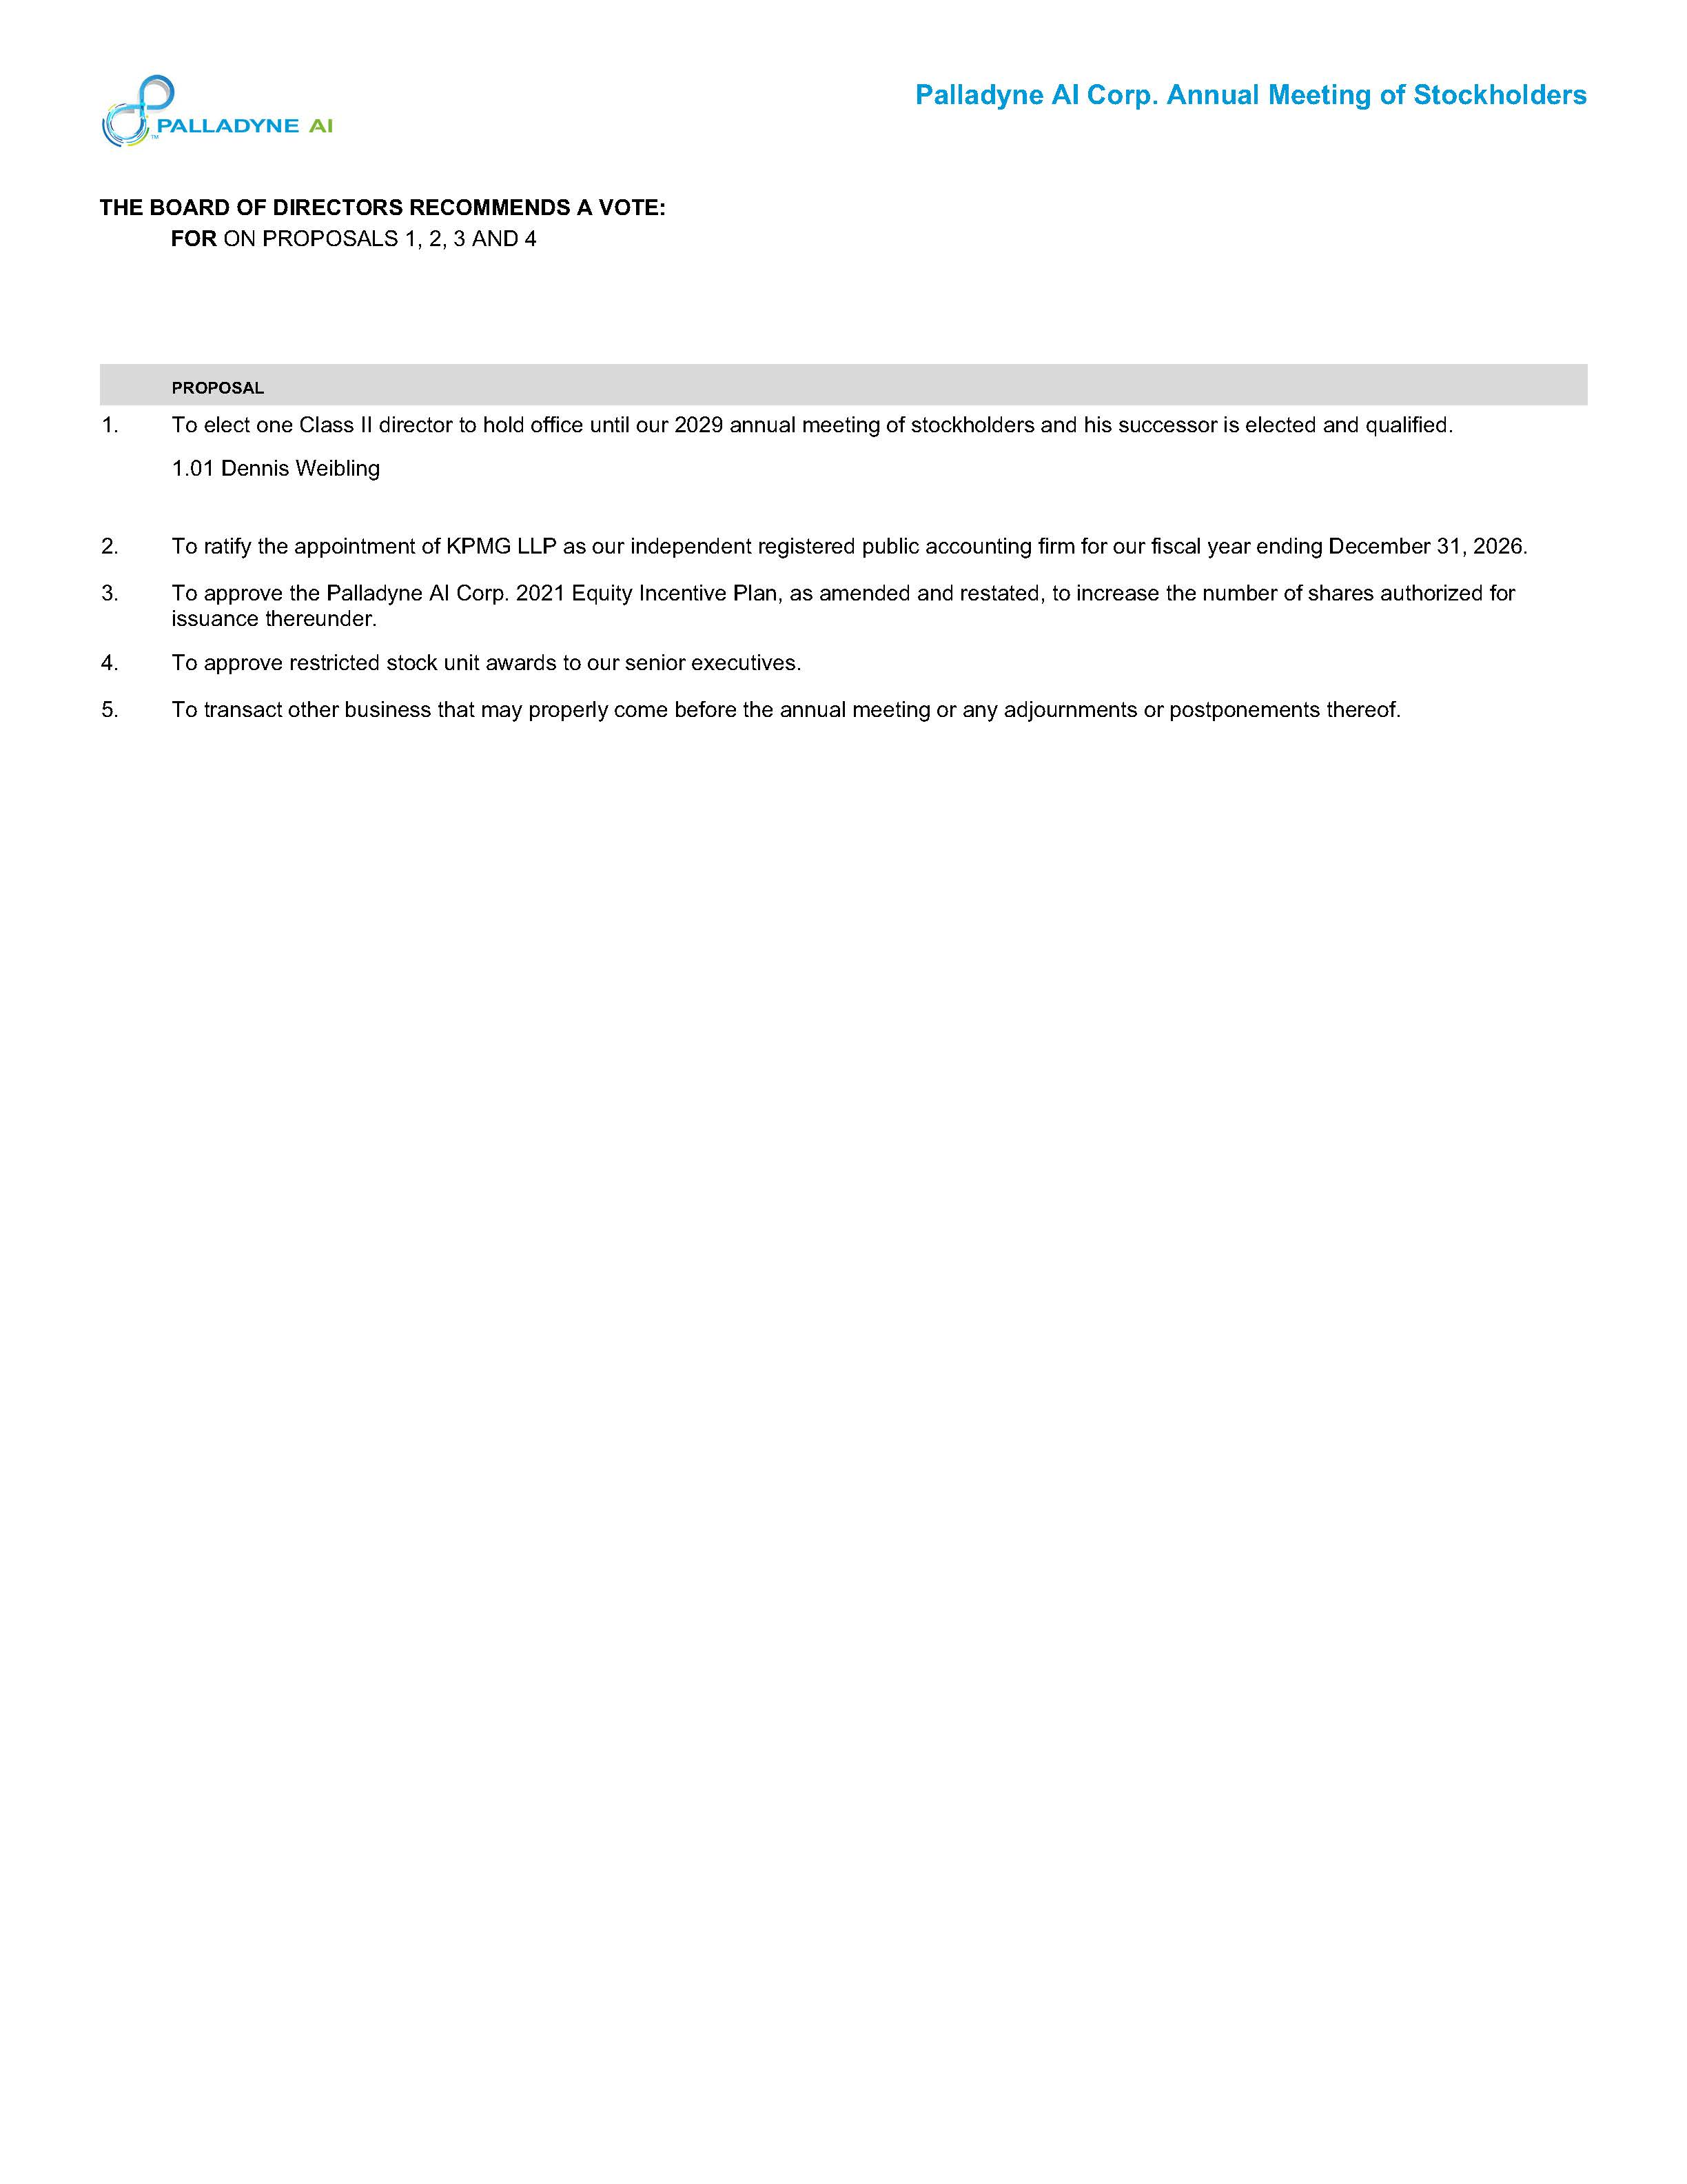
TM PALLADYNE AI Palladyne AI Corp. Annual Meeting of Stockholders THE BOARD OF DIRECTORS RECOMMENDS A VOTE: FOR ON PROPOSALS 1, 2, 3 AND 4 PROPOSAL 1. To elect one Class II director to hold office until our 2029 annual meeting of stockholders and his successor is elected and qualified. 1.01 Dennis Weibling 2. To ratify the appointment of KPMG LLP as our independent registered public accounting firm for our fiscal year ending December 31, 2026. 3. To approve the Palladyne AI Corp. 2021 Equity Incentive Plan, as amended and restated, to increase the number of shares authorized for issuance thereunder. 4. To approve restricted stock unit awards to our senior executives. 5. To transact other business that may properly come before the annual meeting or any adjournments or postponements thereof.

